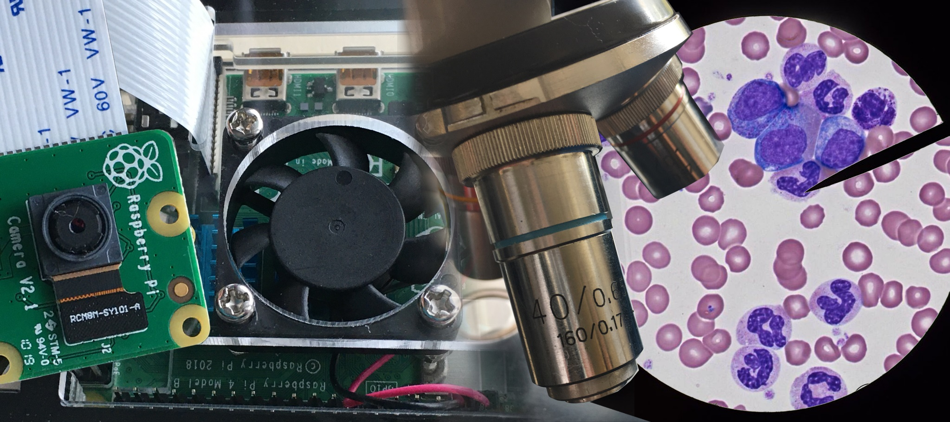

User Manual

Team Puma

www.virtualscope.site

**TABLE OF CONTENTS**

INTRODUCTION: 3

FEATURES: 3

*Create Account* 3

*View Livestream* 3

*View Photos* 3

*Create and Delete Class Passwords* 3

*Track Users’ Logins* 3

*Modify Users Accounts* 3

*Modify microscope* 4

STEP BY STEP INSTRUCTIONS FOR USING VIRTUALSCOPE AS A STUDENT: 4

*Create an Account* 4

*Log Into Website* 4

*View Livestream* 4

*View Photos* 4

STEP BY STEP INSTRUCTIONS FOR USING VIRTUALSCOPE AS AN ADMINISTRATOR: 4

*Log Into Website* 4

*View Livestream* 4

*View Photos* 5

*View and Delete Class Passwords* 5

*Track User Logins* 5

*Modify User Accounts* 5

*View and Configure Microscopes* 5

INTRODUCTION:

VirtualScope is a visual resource for students, educators, and interested individuals. It is a website that allows its users to have live access from remote locations to their microscope projects. With constant streaming, users can access one or more video feeds from a dedicated website at any time from the comforts of their home or work. The website also offers time taken photos of the microscope subject for the user to compare. Administrators can manage and keep track of users. They are also able to modify the live streams and its corresponding microscope.

Users can access the website online at http://www.virtualscope.site with their computer, tablet, and/or mobile device. Each microscope has a dedicated raspberry pi and camera to capture its subject. Multiple livestreams are possible through the connection of the raspberry pi(s) to a live streaming platform, which is embedded on the website. All users simply log into the website to access the livestream and view photos of a microscope’s content. Teachers and/or administrators have more accessibility. They can modify class passwords, track user logins, modify user account(s), and modify microscopes.

This manual explains the many ways in which to use the site in order to get the most out of website http://www.virtualscope.site.

FEATURES:

## Create Account

The goal of this use case is to allow the actor to access the website. If not registered, the actor will register. The actor provides a username, password, and the given class password. The class password is created by the administrator and given to the student. When the account is being created, it is stored in a database. After account creation, the actor may access the system.

## View Livestream

The goal of view live stream is to allow actor access to the microscope video capture. Attached to the eyepiece is a raspberry pi that streams the video to a website. An actor can access the live stream as long as he/she can go online. The video captures content through the eyepiece of a microscope.

## View Photos

The goal of view photos is so the actor may see the progress of the microscope subject in time increments. Because live streaming only shows current development, any past progress of the microscope subject will be lost to the actor. With time interval photos, the actor may look at the subjects past development. The photos are taken at intervals and organized by time.

## Create and Delete Class Passwords

The goal of the class password is to verify that only certain actors may create a student account. Only Administrator(s) may create or delete class password. The Administrator is able to create a class password by adding a course name, the section of that course, and a class password. The Administrator can also choose who can create a student account. A class password is given to a new student user to create his/her account.

## Track Users’ Logins

The goal of the view sign in log is to allow the Administrator to keep track of all the students that are currently using the website. The Administrator is able to search by a desire criterion such as name, date range or all the login history from when users logged in.

## Modify Users Accounts

The goal of the modify user accounts is to allow the Administrator to modify the user account information. The Administrator can delete account by name or delete a batch of users by class. The Administrator may also change a user access to administrator.

## Modify microscope

The goal of this is to allow the Administrator to add a microscope to the database and configure the details of the microscope such as microscope name, experiment name, course name, dates, YouTube streaming link, photo interval, state and description. The Administrator is able to change the photo increment of the picture taken.

STEP BY STEP INSTRUCTIONS FOR USING VIRTUALSCOPE AS A STUDENT:

## Create an Account

(First time users)

1. From the homepage click “Sign up” located at the upper right corner. You will be redirected to the Sign Up page.
2. Next fill in all the following: First Name, Last Name, StarId, Class Password, Username, Password, Repeat Password. The Class Password is supplied by an administrator of the website. The Repeat Password must exactly match the Password.
3. Finally click the Submit button. If successful, you will be redirected to the homepage where you can log in to the website. If unsuccessful, you will stay on the Sign Up page.

## Log Into Website

1. From the homepage, click on “Login” on the upper right hand corner. You will be redirected to the Log In page.
2. On the Log In page, type in your Username and Password then click the Submit button. If successful, you will redirected the Experiments page. If unsuccessful, you will stay on the Log In page.

## View Livestream

1. From the Experiments page find the microscope you want to view and click the “View Live Stream” button. You will be directed to the Live Stream page. Or from the View Photos page, click on the “View the stream” link and you will be directed to the Live Stream page.
2. Click the play button on the video to view the live stream.

## View Photos

1. From the Experiments find the microscope you want to view and click the “View Photos” button. You will be directed to the view photos. Or from the View Live Stream page, click on the “View Archived Photos” button or the “View All” link in the Latest Images box.

STEP BY STEP INSTRUCTIONS FOR USING VIRTUALSCOPE AS AN ADMINISTRATOR:

## Log Into Website

1. From the homepage, click on “Login” on the upper right hand corner. You will be redirected to the Log In page.
2. On the Log In page, type in your Username and Password then click the Submit button. If successful, you will redirected the Experiments page. If unsuccessful, you will stay on the Log In page.

## View Livestream

1. From the Experiments page find the microscope you want to view and click the “View Live Stream” button. You will be directed to the Live Stream page. Or from the View Photos page, click on the “View the stream” link and you will be directed to the Live Stream page.
2. Click the play button on the video to view the live stream.

## View Photos

1. From the Experiments find the microscope you want to view and click the “View Photos” button. You will be directed to the view photos. Or from the View Live Stream page, click on the “View Archived Photos” button or the “View All” link in the Latest Images box.

## View and Delete Class Passwords

1. From the Administrative Panel page, click on the “Class Passwords” button. You will be directed to the Class Passwords page.
2. This page displays all the class passwords with their corresponding ID, Course name, and Section. The page allows you to add or delete a class password.
3. To add a class password, enter in the Course Name, Section, and Class Password and click the “Submit” button. A class password will be added to the existing list and displayed when you hit the button.
4. To delete a class password, find the one you want to delete from the existing list and click the “delete” button on its row. The class password will be deleted, and it should be removed from the class passwords list displayed.

## Track User Logins

1. From the Administrative panel page, click on the “Logins” button. You will be directed to the VirtualScope User Login History page.
2. This page allows you to search the login history of all users by various criteria. When you arrive on the page, there are three options displayed that you may search by: Name, Date Range, List All. Whenever you want to do a new search, simply click on the option you want. Search results are ordered from the most recent logins top down. The result will display row(s) with each row as a login instance. The login instance will display: First Name, Last Name, StarID, Username, User Type, and Timestamp.
3. To find a user’s login by First Name and Last Name, click “Name” and two text boxes will be displayed that allows you to fill in the mandatory first and last name of the user. Click the “Search” button to display the search result.
4. To search for user logins by name and date range, click “Date Range.”
   1. To find all users’ login history by name and date range, click “Date Range”. There are four text boxes that must be filled in: First Name, Last Name, Start Date, and End Date. The date must be in the format month/day/year (MM/DD/YYYY). Click the “Search One” button to display the search result for that one person within that specific date range.
5. To search for all user logins, click the “List All” and displayed will be a description that allows you to see all user login history. Click the “Search” button to display all user logins. (This may be a very long list).

## Modify User Accounts

1. From the Administrative panel page, click on the “User Accounts” button. You will be directed to the Modify User Account page. When you arrive on the page, there is a list of the current users immediately presented under the Existing User Accounts table. There are three additional features on this page.
2. Delete Account by Name: delete a user by first and last name. Click the tab and two text boxes will appear. You must enter in the first and last name. Then you click delete. You will get a prompt that reads “Are you sure you want to delete user account(s)?”. Click OK to delete.
3. Delete Accounts by Class: you can delete an entire class of users. Click the tab and enter into the two text boxes, course number and section. Then you click delete all. You will get a prompt that reads “Are you sure you want to delete user account(s)?”. Click OK to delete.
4. Change User Access: you can change a student to admin. Click the tab and enter into the two text boxes the first name and last name of the user you want to change to admin. You will get a prompt that reads “Are you sure you want to change this user access to admin?” Click OK to change access to admin.

## View and Configure Microscopes

1. From the Administrative Panel page, click on the “Microscopes” button. You will be directed to the Microscope Configurations page.
2. You will be present with a list of microscopes and their current configurations. Click the “Edit” button on any microscope you wish to change. You will be directed to the individual microscope’s page.
3. The fields Experiment Name, Course Name, Availability, and Description are shown on the microscope’s Experiment page.
4. The Youtube Link is the embedded link that is the video on the Experiment’s page.
5. The Youtube RTMP Stream Link is the link provided by Youtube that is the target of the raspberry pi’s stream.
6. The Photo Interval determines the time in minutes between when the raspberry pi camera takes a photo and uploads a photo. If a microscope’s stream is currently live, the change will take place the next time the raspberry pi begins streaming anew.
7. The State determines whether or not the microscope’s experiment page is viewable by students.
8. After any changes, click the “Submit” button.